***Frequently Asked Questions***

**Formatting & Structure:**

1. ***In part 1 when summarizing the study, we should talk about the whole paper (including second cut-off and mechanism). How do we treat replication results? Should we report both, replicated and reported values? Or should we summarize the paper in one paragraph and address replication and its results in another?***
   1. You should summarize the original Hansen paper in 1 paragraph including his research question and design and then for the rest of the replication part (PART 1), you should treat the replication as an independent unrelated Research Report. Presenting the hypotheses we are using, the results and robustness checks that are reflected in the questions. THIS IS ONLY FOR THE REPLICATION PART
   2. For the critique, you should base your arguments on Hansen’s original paper in combination with any insights you might have from the replication!
2. ***Must we explain RDD and its assumptions at some point (in part 1) or is it sufficient to discuss its assumptions and potential threats to identification in part 2?***
   1. The ideal treatment of what an RD design is, its assumptions and why it should be used in this study would be to introduce the key concepts in the first paragraphs of the report briefly, and then throughout the replication and critique relate any robustness finding to assumptions of RDD.
3. ***Should the questions, e.g. about the histograms in Q1, be answered in the code or in the report?*** 
   1. The answer (plot and explanation of the plot) should be on the main .DOC /.PDF file that you submit as text. *The code + 1-3 lines on what the code does should be on the .do file that will be part of the appendix. Example for what should be in the code:*

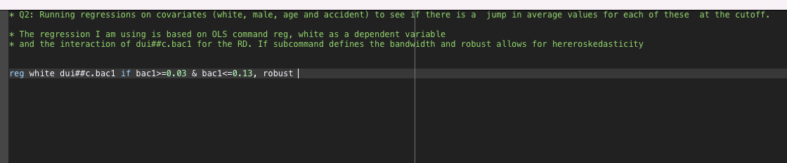

1. ***How should we deal with the lines of code that are in the code but not related to the questions, for example, the rddensity from Cattnaeo, Titunik and Farrell in the code to Q1?***
   1. The code for RDD seminar contains lines of code that you MIGHT not need to use in the assignment. These are not there to throw you off but to provide additional information on RDD and STATA. You should identify on your own which commands correspond with which question of the assignment. All lines of code NOT needed to produce output of the assignment MUST be deleted in the submitted .do file that will be on the Appendix of your PDF
2. ***Should we compare replication results to original Hansen results? How are these comparisons affected by the different dataset? Should we report both, replicated and reported values?***
   1. You are not expected to comment on coefficient by coefficient differences between Hansen’s work and your replication in the report. (For example, Hansen finds X effect in Table 1, I find X+-). The main reason for that is because we don’t have his data and therefore comparisons are not based on the same information. You should report your results and explain them as they were new unique results that are being described in an academic paper.
   2. In terms of describing the data, you should explain what each variable that you use is reflecting and how it’s measured (based on available information). No need to explain why they are different than the original dataset.
   3. FOR PART I: You should NOT report both Hansen’s values and your replication on the report. Only your replication.
   4. FOR PART II: You can mention Hansen’s values/coefficients/results but NOT in relation to yours.
3. ***Should we comment on the packages we use, particularly, if we use other packages as in the code?***
   1. You should do that in your own words on the .do file but not in the main report
4. ***Are we allowed to add more plots if they support our arguments?***
   1. You are allowed, and actively encouraged, to produce any additional table/graph/output that can support your critique arguments
5. ***Where should we get the data for the assignment (Github or Moodle)?***
   1. Data and do file should be on the RDD Seminar MOODLE page
6. ***Why are the two histograms different? And why do we check both?***
   1. This is part of what you need to answer in the assignment. Remember the key thing about Question 1 is eye-balling the data. The answer lies on how the two histograms treat the main variable. Check the raw data on the data editor and try to think why heaping appears in one of the histograms.
7. ***Where should I report answers to the questions? Do file or report?***
   1. See details above, but answers and description of results MUST be in the main report. Code and brief explanation of what the code does MUST NOT be in the main report, only in the .do file.